**CLOUD COMPUTING** -**AWS ESSENTIALS**

**DAY-3 ASSIGNMENT**

**LAUNCHING WINDOWS INSTANCE:**

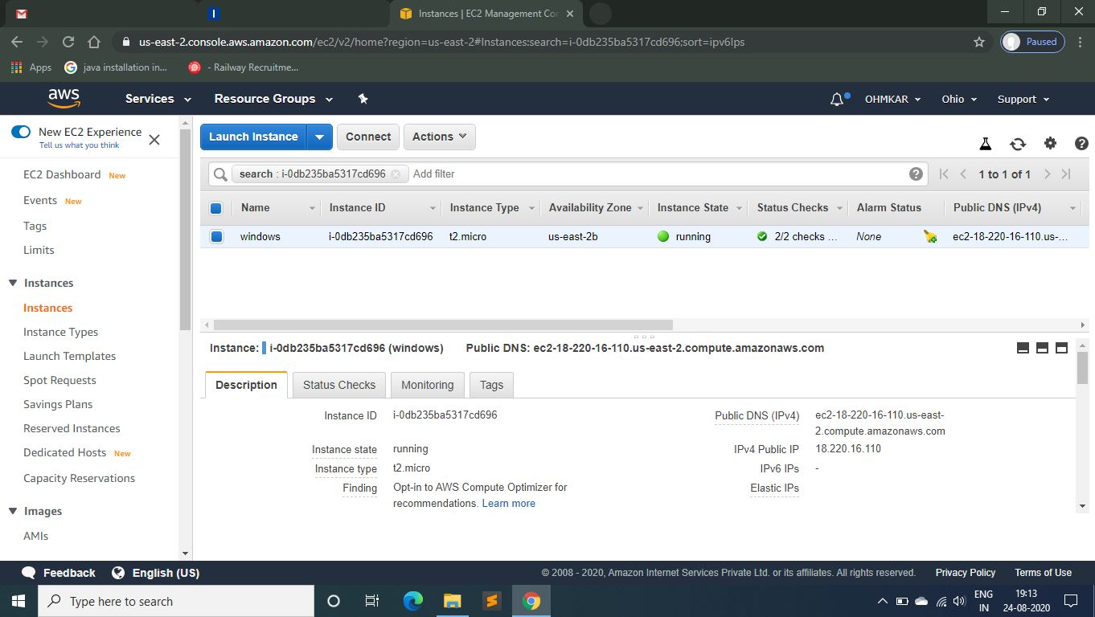

**INSTALLING IIS WEB SERVER ON WINDOWS INSTANCE:**

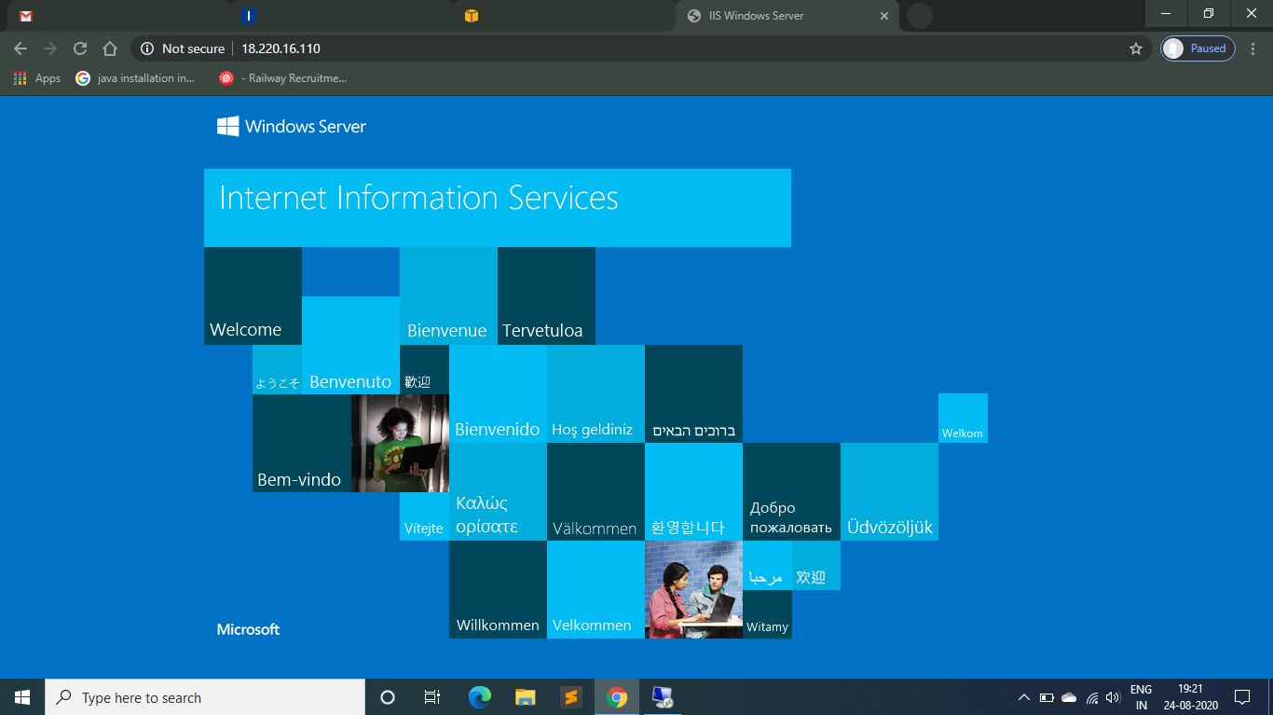

**LAUNCHING UBUNTU INSTANCE:**

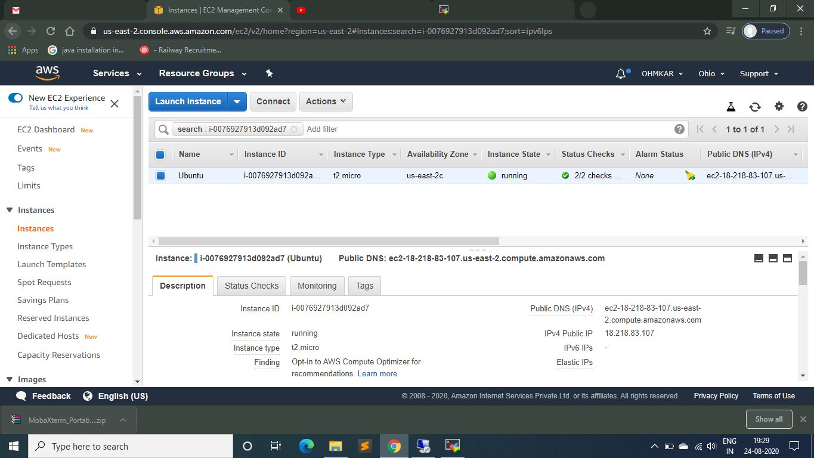

**INSTALLING NGINX SERVER IN UBUNTU INSTANCE:**

